**NAME : DIVYANSHU SHARMA**

**PES1UG20CS806**

**CN LAB : WEEK 7**

**IPv4 Addressing and Static Routing**

**Objective:** To setup a network with two routers and exchange packets across routers.

**Hardware Requirements:**

• Desktops/Laptops: 4

• Switch : 3

• Patch Cords (1.5m): 6

• External NIC : 2

**Software Requirements:**

• Wireshark Tool

• Ubuntu Linux Operating System

**Topology Description:** Design a network with at least 2 router networks. Host Ha should be able to communicate with Host Hd using newly assigned addresses.

**Task 1:** Assign IP addresses to all computers A, B, C and D (Source Host Ha, Router R1, Router R2 & Destination Host Hd)

**Step 1:** Assign the IP address to the Ha.

**$** sudo ip addr add 172.16.10.1/24 dev eth1

**$** ip addr show

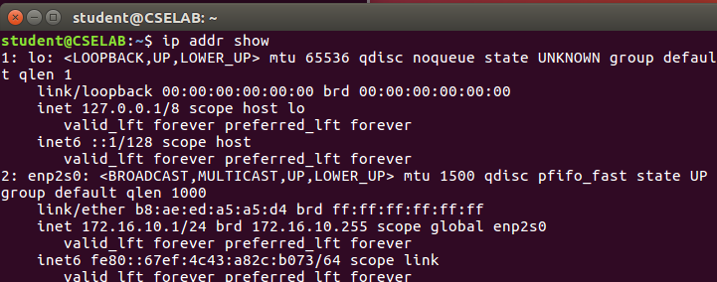

**Step 2:** Assign the IP address to R1.

**$** sudo ip addr add 172.16.10.201/24 dev eth1

**$** sudo ip addr add 172.16.11.1/24 dev eth2

**$** ip addr show

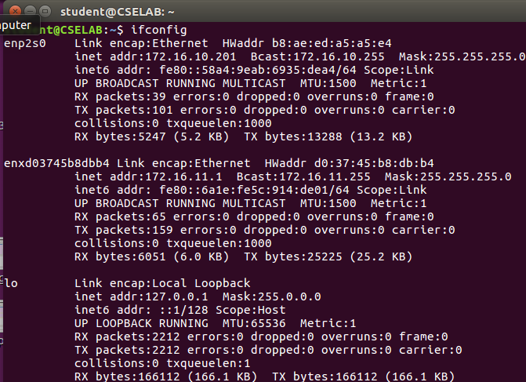

**Step 3:** Assign the IP address to R2.

**$** sudo ip addr add 172.16.11.201/24 dev eth2

**$** sudo ip addr add 172.16.12.1/24 dev eth1

**$** ip addr show

**Step 4:** Assign the IP address to the Hd.

**$** sudo ip addr add 172.16.12.201/24 dev eth1

**$** ip addr show

**Note 1:** As we know the machines are physically on the same LAN, so we can get ICMP redirect messages from other machines. Now disable accepting the ICMP redirect packets. On host machines Ha and Hd, give the following command:

**$** sudo sysctl –w net.ipv4.conf.all.accept_redirects=0



**Note 2:** As we know the machines are physically on the same LAN, so we can get ICMP redirect messages from other machines.Thus, disable sending of the ICMP redirect packets by these routers with aliased interfaces. Give below command in router machines R1 and R2.

**$** sudo sysctl –w net.ipv4.conf.all.send_redirects=0

G:\IMAGES\BANGALORE\BANGALORE\PESU UNIVERCITY BTECH\PESU\2ND YEAR\4th SEM\Computer Netwok Lab\WEEK 7\g.png

**Task 2:** Converting machines B and C into routers.

**Note 1:** Check if IP forwarding is enabled or not. **$** sysctl net.ipv4.ip_forward net.ipv4.ip_forward = 0

**Command** to set the value of net.ipv4.ip_forward in R1 & R2 is given below:

**At R1: $** sudo sysctl –w net.ipv4.ip_forward=1

**At R2: $** sudo sysctl –w net.ipv4.ip_forward=1

G:\IMAGES\BANGALORE\BANGALORE\PESU UNIVERCITY BTECH\PESU\2ND YEAR\4th SEM\Computer Netwok Lab\WEEK 7\h.png

**Task 3:** Verify the connection between Ha and Hd using ping command.

**At Ha: $** ping 172.16.10.1 (Local network)

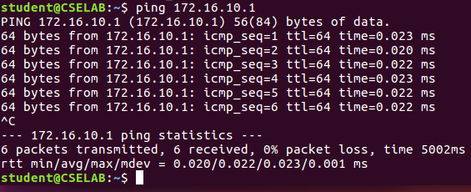

**At Hd: $** ping 172.16.12.1 (Local network)

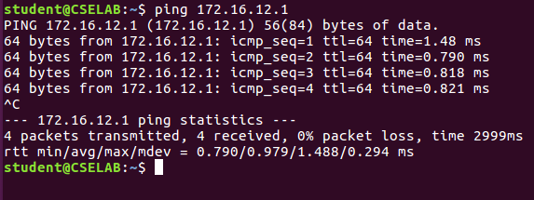

**Task 4:** Insert routing table entries on each system to direct ipv4 packets to ping across the networks.

**At Ha: $** sudo ip route add **172.16.12.0/24 via 172.16.10.201**

**$** sudo ip route add **172.16.11.0/24 via 172.16.10.201**

**$** ip route show

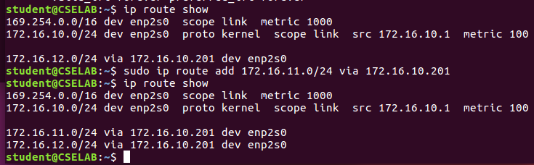

We need to have routing table entries for other networks such as 172.16.11.0/24 and 172.16.12.0/24.

**At R1: $** sudo ip route add **172.16.12.0/24 via 172.16.11.201**

**$** ip route show

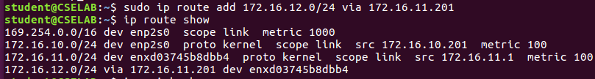

Since R1 is connected to 172.16.10.0/24 and 172.16.11.0/24 networks we need to have one routing table entry to 172.16.12.0/24.

**At R2: $** sudo ip route add 172.16.10.0/24 via 172.16.11.1

**$** ip route show

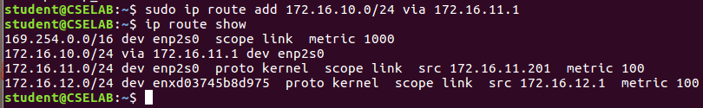

**At Hd: $** sudo ip route add 172.16.10.0/24 via 172.16.12.1

**$** sudo ip route add 172.16.11.0/24 via 172.16.12.1

**$** ip route show

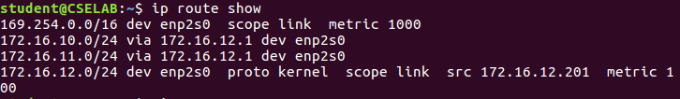

**Task 5:** After adding routing table. again verify the connection from Ha and Hd using ping command.

**Step 1:** Testing path from Ha and Hd

**$ ping** 172.16.12.1 and $ ping 172.16.12.201

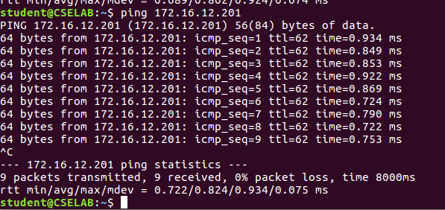

**Step 2:** Testing path from Hd and Ha

**$ ping** 172.16.12.1 and $ ping 172.16.12.201

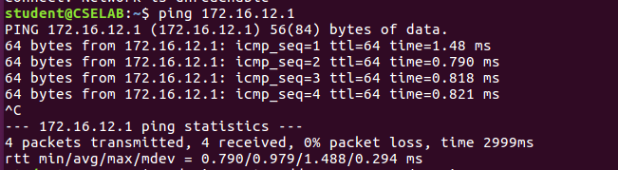

**Task 6**: Check each system neighbor to verify the connection.

G:\IMAGES\BANGALORE\BANGALORE\PESU UNIVERCITY BTECH\PESU\2ND YEAR\4th SEM\Computer Netwok Lab\WEEK 7\x4.png

**Task 7:** Capture packets from Ha and Hb using Wireshark.

**Step 1:** Capture packets from Ha and Hd.

**At Ha:**

**T1: $** sudo wireshark T2: $ ping 172.16.12.201

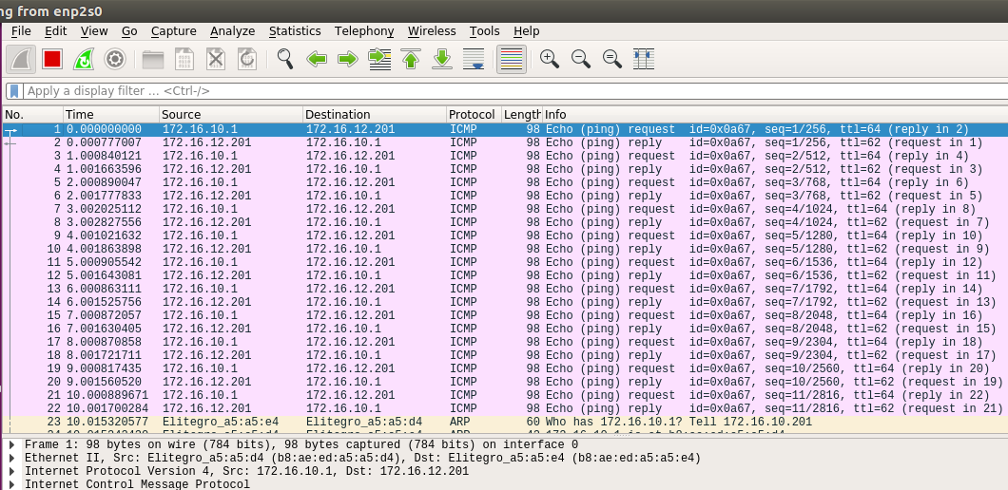

**Step 2:** Capture packets from R1 using both eth1 and eth2 interfaces.

**$** sudo wireshark

**At eth1:**

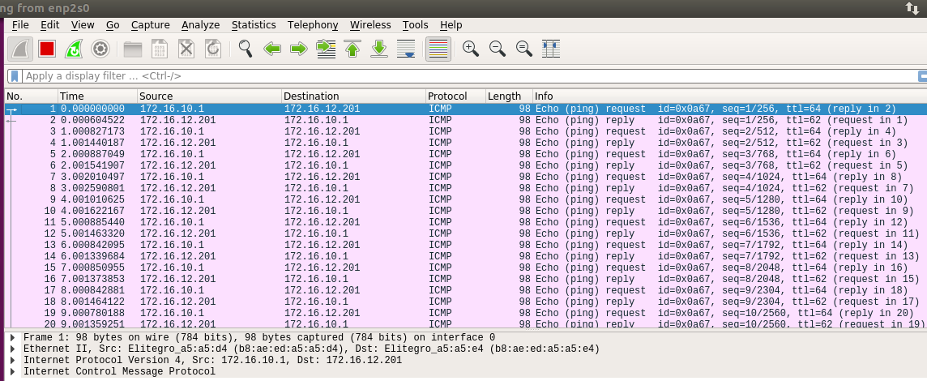

**At eth2:**

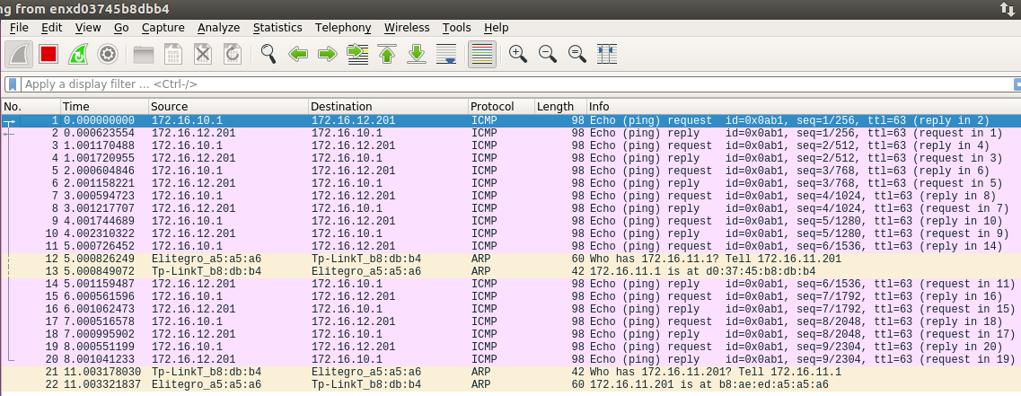

**Step 3:** Capture packets from R2 using both eth1 and eth2 interfaces.

**$** sudo wireshark

**At eth1:**

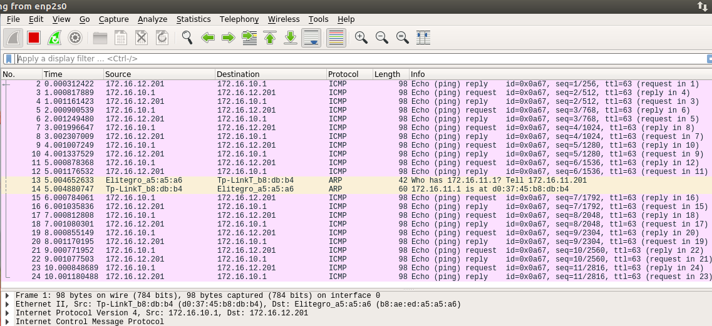

**At eth2:**

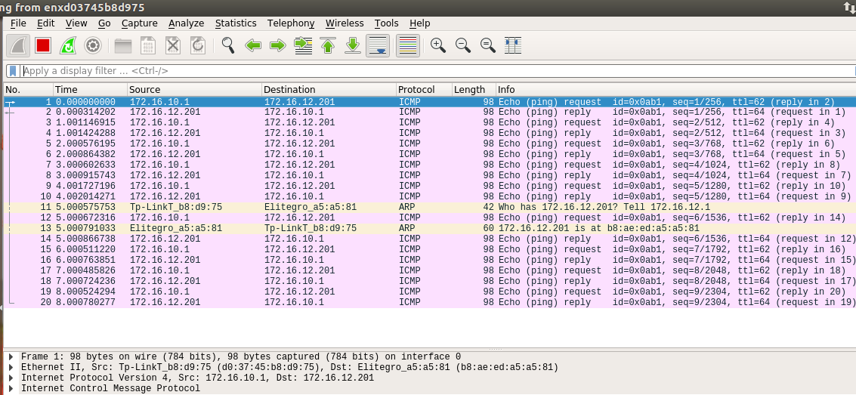

**Step 4:** Capture packets from Hd and Ha.

**At Hd:**

**T1: $** sudo wireshark

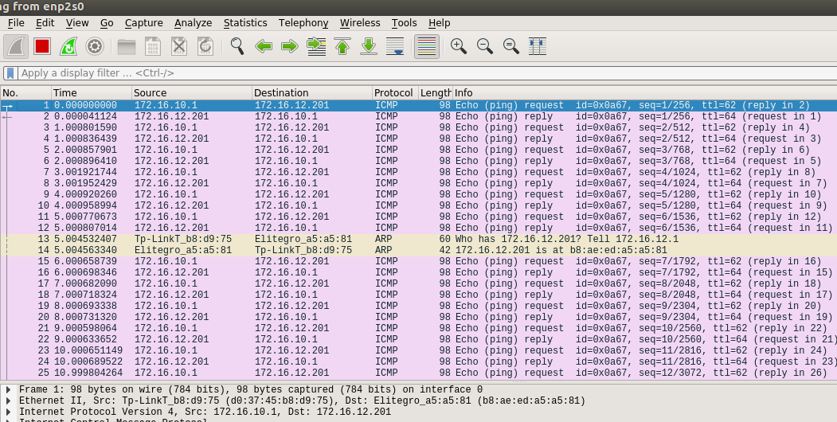

**Exercises:** Send http packets from Ha to Hd and capture Wireshark for Ha and Hd files

**Apache Service at Ha**

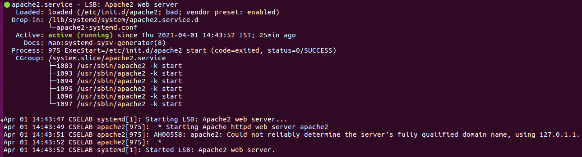

**R1 Capturing HTTP packet**

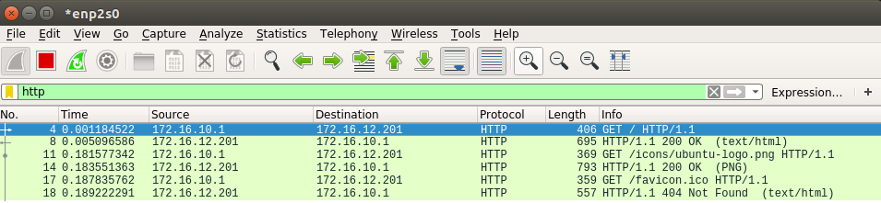

**R2 Capturing HTTP packet**

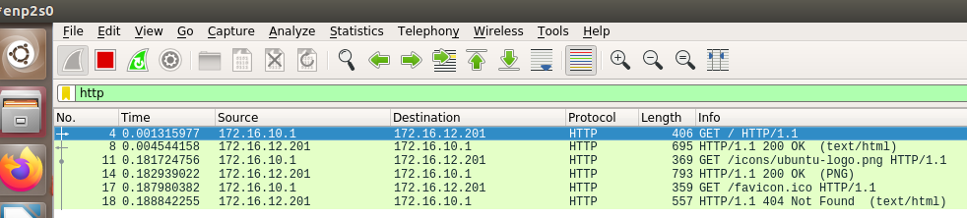

**Hd Capturing HTTP packet**

